**Disciplined Entrepreneurship Workbook**

# Step 16: Set Your Pricing Framework

## Worksheet

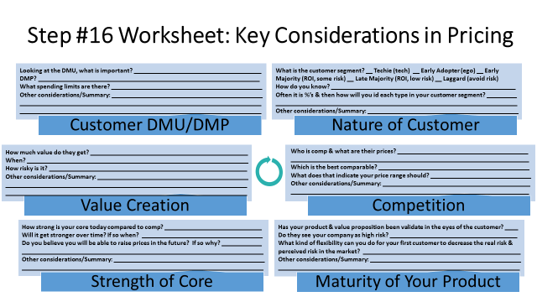

1. **Customer DMU/DMP**

Looking at the DMU, what is important?  
**Simplicity, transparency, low upfront commitment, and visible early value.**

DMP?  
**End users make the decision, occasionally influenced by economic buyers in B2B or group use cases.**

What spending limits are there?  
**Most solo travelers and students are sensitive to prices above €10/month. B2B cases can stretch to €50/month if value is clear.**

Other considerations/Summary:  
**Ensure pricing tiers reflect usage levels and user type. Offer loyalty incentives to encourage continued use.**

1. **Nature of Customer**

What is the customer segment?  
**Early Adopter (ego/value driven) and Early Majority (ROI + convenience).**

How do you know?  
**Feedback from digital nomads, student clubs, and solo travelers suggests they seek modern, tech-driven solutions but care deeply about cost and convenience.**

Often it is %’s & then how will you id each type in your customer segment?

1. **30% Early Adopters – Tech-savvy users, often first to try new travel tools.**
2. **50% Early Majority – Value-conscious, pragmatic users who follow proven solutions.**
3. **15% Late Majority – Risk-averse, slower adopters needing strong reassurance.**
4. **5% Laggards – Least likely to switch from traditional tools or methods.**

Other considerations/Summary:  
**The majority expect a freemium tier to "try before they buy." Upsell must happen via demonstrated value, not pressure.**

1. **Value Creation**

How much value do they get?  
**High—users save time, avoid tourist traps, and discover authentic local gems.**

When?  
**Within the first 1–3 days of use.**

How risky is it?  
**Low for freemium, but risk rises slightly for paid tiers without upfront proof of value.**

Other considerations/Summary:  
**Emphasize emotional value (memorable experiences) and practical support (logistics, safety).**

1. **Competition**

Who is comp & what are their prices?  
**Nomad List (€75/year), TripIt Pro (~€45/year), Airbnb Experiences (fee per booking), Lonely Planet (€35/year).**

Which is the best comparable?  
**Nomad List (community + discovery) and TripIt (trip planning functionality).**

What does that indicate your price range should be?  
**€5–€10/month or €50–€80/year for premium tools and curated experiences.**

Other considerations/Summary:  
**We can undercut competitors initially to attract volume, then add premium upsells.**

1. **Strength of Core**

How strong is your core today compared to comp?  
**Competitive in community-based discovery and cultural immersion. Still maturing in AI itinerary and UX.**

Will it get stronger over time? If so when?  
**Yes—with data accumulation and local expert partnerships. Expected within 6–12 months.**

Do you believe you will be able to raise prices in the future? If so why?  
**Yes—through added personalization, concierge services, and user loyalty.**

Other considerations/Summary:  
**Our strength lies in building trust and intimacy with our users, unlike transactional travel apps.**

1. **Maturity of Your Product**

Has your product & value proposition been validated in the eyes of the customer?  
**Initial validation is strong from beta testers, especially among solo travelers and students.**

Do they see your company as high risk?  
**Some do, especially if unfamiliar. Early adopters are more forgiving.**

What kind of flexibility can you do for your first customer to decrease perceived risk?  
**Offer extended trials, personalized onboarding, and clear cancellation terms.**

Other considerations/Summary:  
**Community testimonials and social proof are essential to building confidence and overcoming resistance.**

1. **Initial Decision and Rationale**
2. What unit of product are you using for pricing (carried forward from Step 15, Design a Business Model)?

**We are using a freemium + premium subscription model, where users can access basic features for free and upgrade to a monthly or annual subscription for advanced tools, curated experiences, and offline support.**

1. Based on your analysis, what is the price range that is most appropriate and why?

**The most appropriate price range for premium users is €5–€10/month or €50–€80/year. This aligns with competitors like Nomad List and TripIt, while still offering flexibility for younger, budget-conscious users. The price reflects Tourmate’s value in convenience, cultural authenticity, and tech-based personalization.**

1. In the first year, what do you believe your initial listed price will be, and what will be the effective price to the market and why? (The “effective price” is the actual price your customer pays after discounts.)

**In the first year, our initial listed price will be €7/month or €65/year. However, due to promotions, extended trials, and discounts, the effective market price is expected to average around €5.50/month.**

1. Sanity Check: What is your expected estimated marginal cost (cost to produce a unit of product, excluding one-time setup costs)? Does your price per unit significantly exceed your estimated marginal cost in the long term?

**Estimated marginal cost per user is under €1/month (mostly cloud infrastructure, customer support). The long-term price significantly exceeds marginal cost, allowing sustainable growth and reinvestment into user experience and support.**

1. **Test to Validate**
   1. In setting your pricing framework, what hypotheses are you assuming to be true?

**We hypothesize that users are willing to pay for curated, localized travel support that saves time, enhances cultural immersion, and improves the quality of their experiences. Additionally, we believe that most of the value perceived by users—and therefore their decision to upgrade—occurs within the first week of using the platform. We also assume that introducing discount-based offers and referral incentives will significantly improve both customer retention and lifetime value.**

* 1. What experiments will your run to test your hypotheses?

**To test these hypotheses, we will run A/B tests using different pricing tiers and bundled feature sets to see which combinations drive the most conversions. We will also track onboarding engagement to evaluate how early interactions with the app influence freemium-to-premium upgrade behavior. Furthermore, we will launch a referral program that provides a one-month premium extension for every successful invite, enabling us to measure the impact of social sharing and community engagement on customer acquisition and retention.**

* 1. What information will show that your hypotheses are valid or invalid?

**The hypotheses will be considered validated if at least 10% of freemium users upgrade to a paid plan within 30 days. Additionally, we expect to see at least 60% of these paid users continue their subscription into the second month, indicating meaningful value and satisfaction. Lastly, if 15% or more of freemium users make use of the referral program to invite friends, it will demonstrate the viral growth potential of our pricing and incentive strategy.**

* 1. How long will you give the experiments to run?

**These pricing validation experiments will be conducted over a four-week period. During this time, we will use platform analytics, user feedback surveys, and conversion tracking to monitor performance, understand behavior, and refine our pricing strategy based on real-time data.**